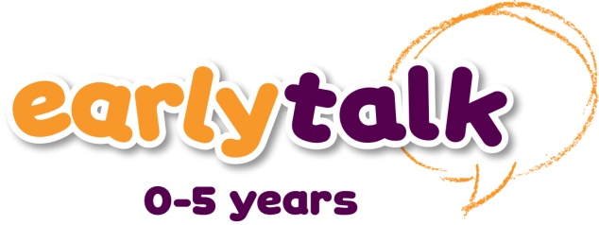

Early Talk Training Materials Order Form
YOUR ORDER |  | Unit price | Qty |  | Total
Supporting Communication and Language - Participant Book |  | £20 |  | 4
Working with Under 3s - Participant Book |  | £20
Working with Parents - Participant Book |  | £20 |  | 4
Early Talk Toolkit |  | £85 |  | 1
Early Talk Supportive Accreditation - Pre-School Setting Manual |  | £250
Early Talk Enhanced Accreditation - Pre-School Setting Manual |  | £250
Early Talk Specialist Accreditation - Pre-School Setting Manual – please speak to Speech and Language UK
Promotional materials
Early Talk 0-5 promotional leaflet pack (25 leaflets) |  | free
UK Postage*(please remove as appropriate) |  |  |  | £10 / £20
Grand Total*
*Postage- Please add £10 for orders under £1,000 and £20 for orders over £1,000
For international orders please contact Speech and Language UK

SPEECH AND LANGUAGE UK LICENSED TUTOR DETAILS

Training must be delivered by one of our approved Licensed Tutors/Mentors. We will not be able to process this order without the Licensed Tutor/Mentor’s details.

Please ensure that you include the Licensed Tutor/Mentor’s name. If you do not know the number or organisation this can be left blank.
Licensed Tutor/Mentor Name* | Organisation (optional)

INVOICE DETAILS: Payment for goods can be made by the Tutor/Mentor, the organisation receiving training or the organisation requisitioning training. Payment by
invoice (payment terms 28 days) is acceptable provided that the payer is a public sector organisation or someone to whom Speech and Language UK has already granted credit facilities.
If payment by cheque, goods will be sent once funds have cleared. Cheques can be made payable to ‘Speech and Language UK’.
Name |  |  |  |  |  | Role |  |  |  |  | Date
Purchase Order No.
Will an official purchase order be issued by a 3rd party? |  |  |  |  |  |  | (please remove as appropriate) Yes / No
Organisation name to appear on invoice
Address
 |  |  |  |  |  |  |  |  |  | Postcode
Phone |  |  |  |  |  |  | Email
If you would like to pay by credit card, please give us a call on 020 7843 2552.

DELIVERY INSTRUCTIONS
 | Name |  |  |  |  |  |  |  |  | Role
 | Organisation/School
 | Address
 |  |  |  |  |  |  |  |  |  |  | Postcode
 | Phone |  |  |  | Delivery Deadline |  |  |  |  |  | Date of training
 | Delivery instructions
 | CUSTOMER SIGNATURE
 | Signed |  |  |  |  |  |  |  | On behalf of
 | Name |  |  |  |  |  | Role |  |  |  |  |  |  | Date

Please return completed order form to:
EMAIL: info@speechandlanguage.org.uk | POST: Early Talk, Speech, and Language UK, 31 Angel Gate, Goswell Road, London, EC1V 2PT | 020 7843 2515

