Email template to parents and carers

Copy, and paste the email template below to share No Pens Day with parents and carers and get them involved in raising vital funds.

_________________________________________________________________________________

Dear Parent/Guardian,

As you may already know, Wednesday 27th November is No Pens Day! Our [school/setting/class] is excited to be joining many others around the UK for a chatty day of fun and fundraising.

This is where we need your help!

As part of No Pens Day, we are asking each pupil to bring an item of their choosing and tell their peers about it as part of the biggest-ever show and tell! This will give your child a chance to practice their communication skills, listen and talk to others in their class about something that matters to them.

We’re also asking each pupil to bring in £1 to the children’s charity Speech and Language UK. These vital funds will help raise awareness about the 1 in 5 children in the UK with speech and language challenges.

How to donate
Give £1 to your child to bring in, text NOPENSDAY to 70470 to donate £1, or click here to make a donation online. (Don’t forget to write your child’s school in the donation message!)

You can also donate by scanning this QR code:
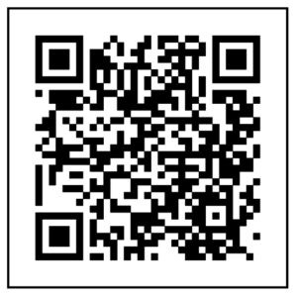
Together, we can give every child struggling with talking and understanding words the skills they need to face the future with confidence.

Thank you for your continued support.

Yours faithfully,
[name/signature]

